North Carolina Testing Program Requirements:  9TH  10TH  CCRG: College Career Readiness Graduate(  Biology EOC  English II EOC  NC Math I  11Th  ACT- Assessment  12Th  Work-Keys  http://www.ncpublicschools.org/accountability/testing/  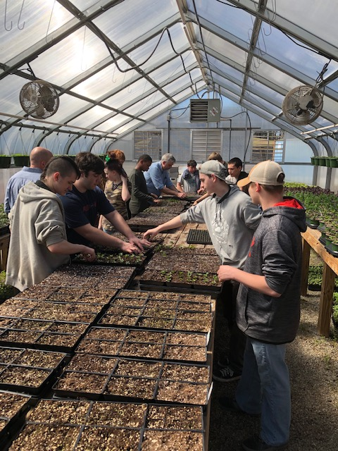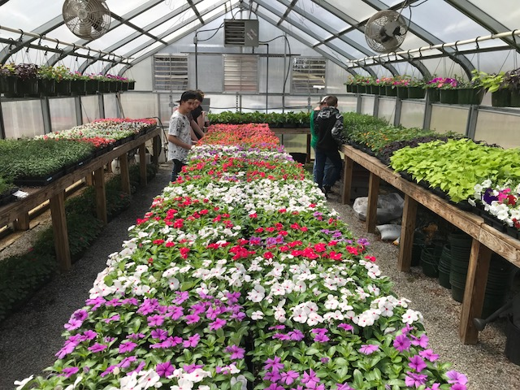 | Occupational Course of Study Staff 2020-2021  9th-12th Grade Academic Teachers:  Dan Carroll  Natalee Lee  Sherrie Reid  Thomas Young  Teacher Assistants:  Bobby Harris  Angela Mace  Tina Thompson  OCS High School Counselor:  Lyndsay Morris (Last names P-Z)  Brandon Smith (Last names G-O)  Kendall Waugh (Last names A-F)  Glenda Glenn 9th | 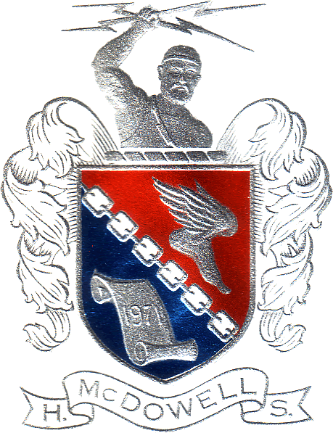  McDowell High School  Occupational Course of Study  (OCS)  The Occupational Course of Study is one of two courses of study a student with disabilities may complete to graduate with a high school diploma  The Occupational Course of Study is an outgrowth of North Carolina’s federally funded Systems Change Transition Project. The Occupational Course of Study was approved in May 2000. The following is a description of the OCS that is offered in McDowell County.

WHO CAN ENROLL?  Any student that:  - Has an IEP (Individual Education Plan)  - May not otherwise earn a high school diploma  - Meet requirements identified in the OCS recommendation form and parent/student approval  HOW IS THE DECISION MADE?  - The IEP team makes recommendations for a particular student based on the above information and their POST SCHOOL TRANSITION NEEDS AND GOALS.  - FINAL SELECTION OF THE OCCUPATIONAL COURSE OF STUDY IS A STUDENT AND PARENT CHOICE AND NOT AN IEP TEAM DECISION. OCS should only be considered after the general curriculum has been delivered in the classroom with modifications, supplemental aids and services, and the student has been continually unsuccessful. | OCCUPATIONAL COURSE OF STUDY REQUIREMENTS  - Students are required to complete Career/Technical Education credits, Health, and PE and electives, as needed to complete local graduation requirements.  - Each student must complete 150 hours of School-Based Training. Examples include Titan Greenhouse, Titan Detail and Recycling.  - Each student must complete 225 hours of Community-Based Training. Work sites include Shear Illusions, Holiday Laundry, Go Grocery Outlet, Bus Garage and Head Start.  - Each student must complete 225 hours of paid employment, or unpaid vocational training, unpaid internships, paid employment at community rehabilitation facilities, and volunteer and/or community service hours.  - Each student must have a career portfolio documenting completion of course of study requirement. | Course Requirements  9th Grade:  Occupational English 1  Introduction to Math 1  Applied Science  Occupational American History 1  Occupational Preparation 1  Health/PE  Elective  10th Grade:  Occupational English 2  Occupational NC Math 1  Occupational NC Biology  Occupational American History 2  Occupational Preparation 2 (Year Long)-Completes SBT 150 hrs requirements  3 Electives or Career/Technical Courses  11th Grade:  Occupational English 3  Financial Management  Occupational Preparation 3  Occupational Preparation Lab 11th -2 periods (CBT 225 Hours)  4 Electives or Career/Technical Courses  12th Grade:  Occupational English 4  Occupational Preparation 4  6 Electives or Career/Technical Course  Senior Release or Electives (Senior release to help meet the 225-hour requirement.)

